Review for American History I Exam

Unit 1: Exploration- Colonization
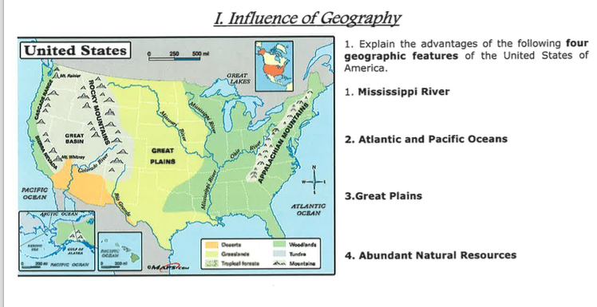
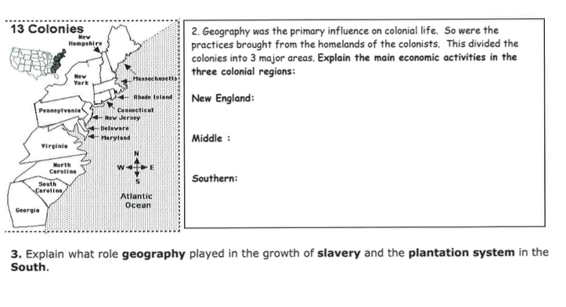
Key ideas for review:
Mercantilism
Middle passage/ triangular trade
Jamestown
Puritans, Pilgrims
Enlightenment, Great Awakening
13 Colonies
Mayflower Compact
House of Burgesses

Unit 2: American Revolution

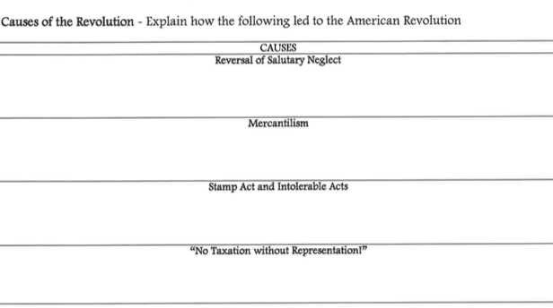
Why did England need to tax colonists after 1763?________________________________
Events leading to American Revolution
Tea Act > Boston Tea Party > England’s reaction
Boston Massacre
1st and 2nd Continental Congress
Why was the Declaration of Independence written?
3 ideas on government expressed in the Declaration of Independence:

American Revolution basics:
1st shots fired-
Turning points-
 | Patriots | British
Strengths

Weaknesses

How did the war end?
Treaty/ closure-

UNIT 3- New Nation
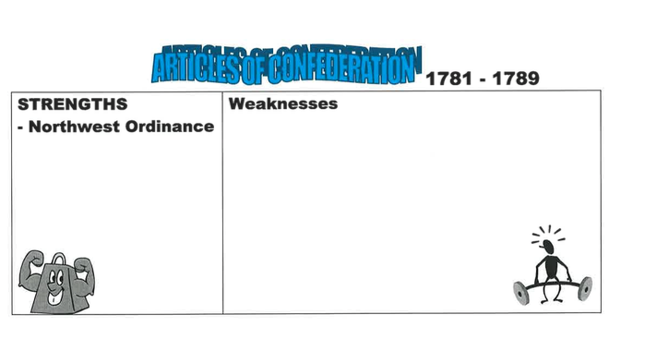
Shay’s Rebellion- ___________________________________________________________________________________________
_________________________________________________________________________________________________________________
_________________________________________________________________________________________________________________

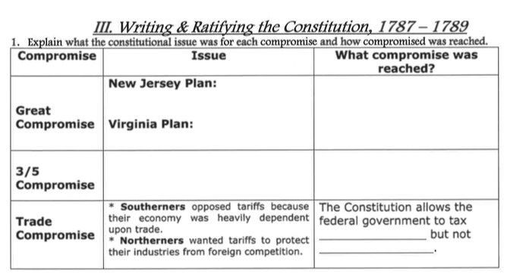
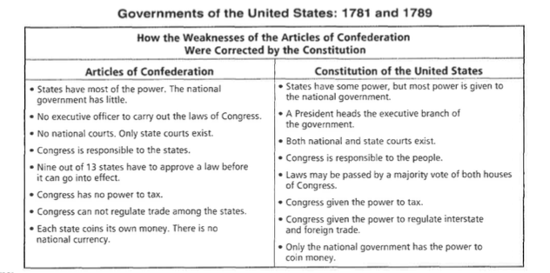

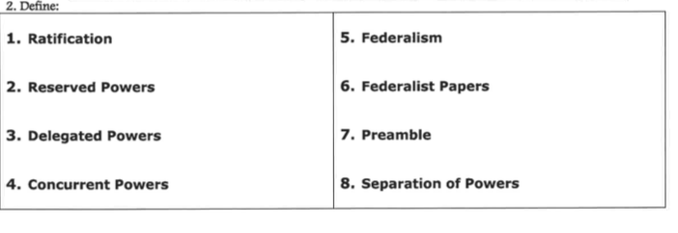

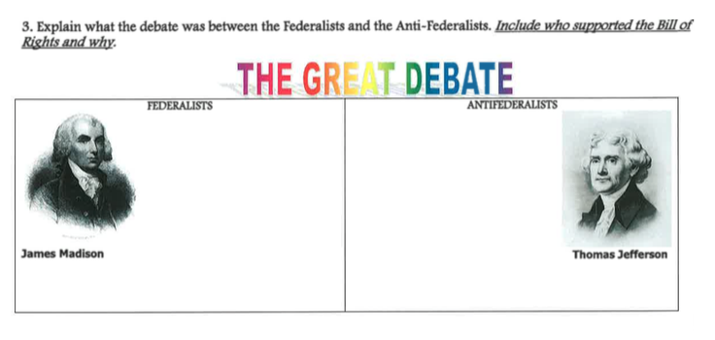

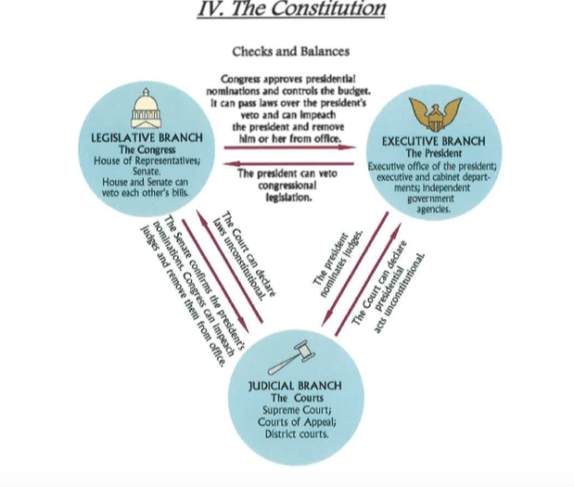

Unit 4: Rise and Fall of the Federalist
Important for review-
Washington’s Farewell Address
Marbury v. Madison
Kentucky and Virginia Resolutions of 1798
Monroe Doctrine

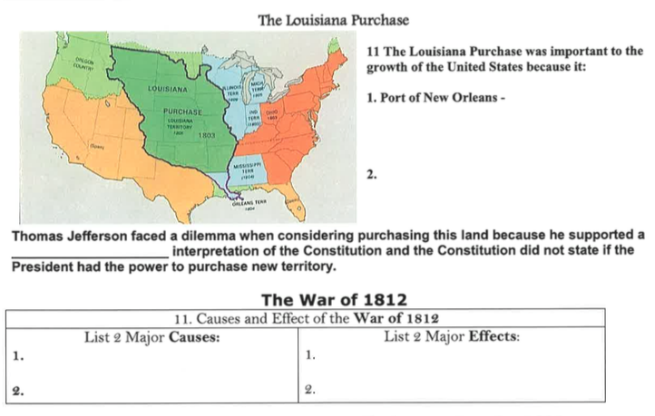

Unit 5: Nationalism, Sectionalism, Expansion
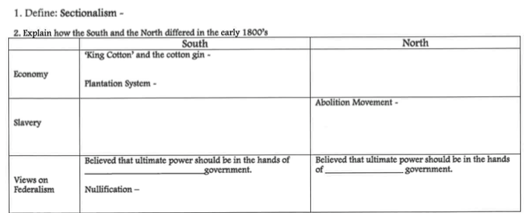

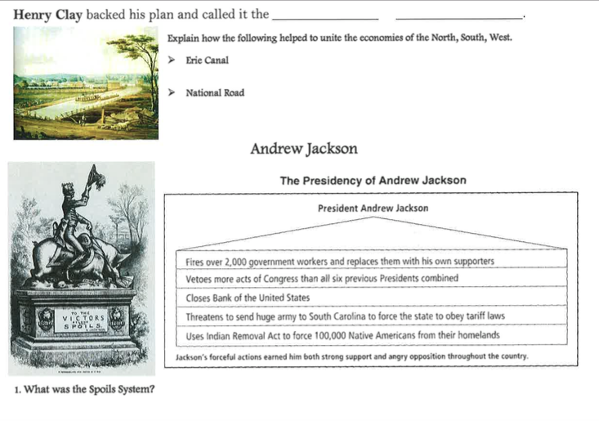
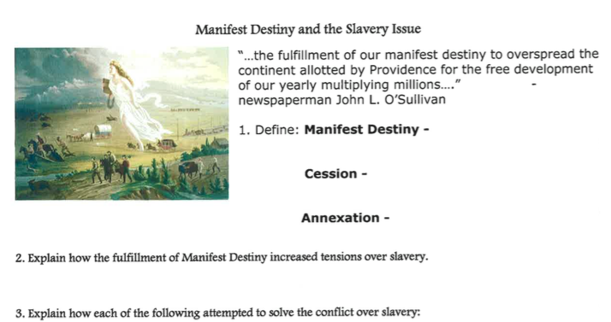
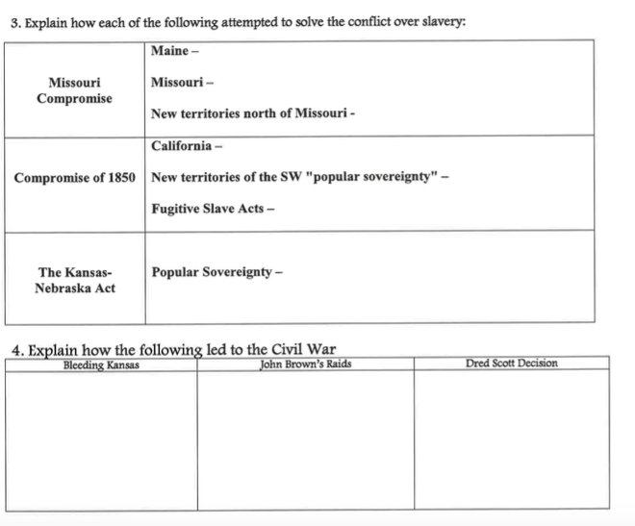

Unit 6: Civil Crisis, Civil War, Reconstruction

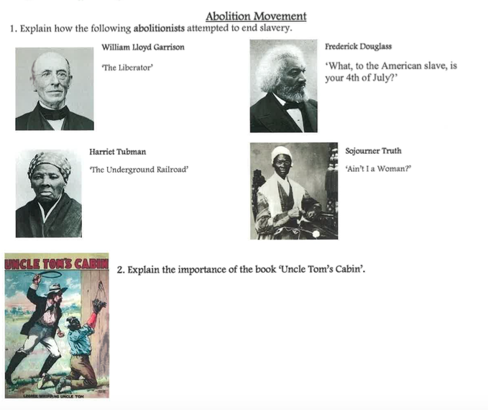
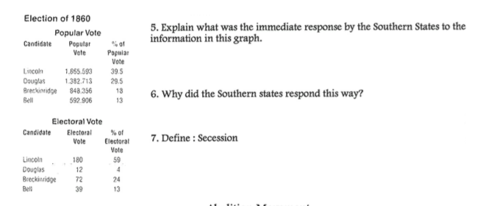

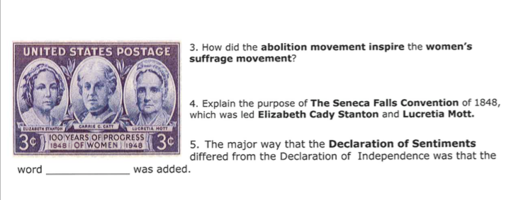

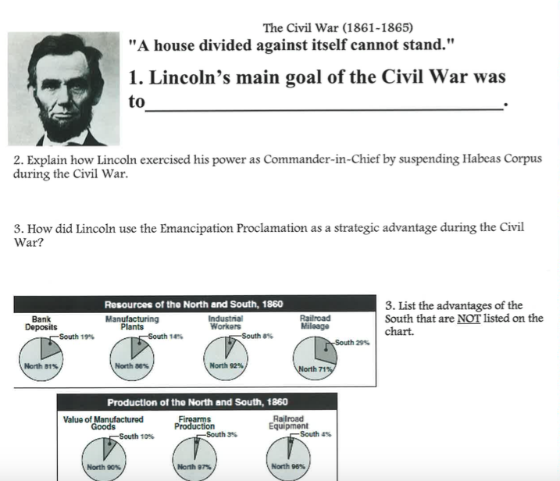

Also important:
Reasons for secession
Why did slavery exist in the South and not North?
Civil War basics-
first shots
turning points
Emancipation Proclamation
Gettysburg address
surrender
key people
